Figure List
PartⅠ

Chapter7 Others

Fig.7.1 Interactive forces versus parallel particle spacing (Ishibashi and Hazarika, 2010)
Fig.7.2 Electrical double layer of solid surface
Fig.7.3 Electro-osmotic flow in soil pores
Fig.7.4 Principle of electro-osmosis (Ishibashi and Hazarika, 2010)
Fig.7.5 Layout of Electro-osmosis System (Casagrande et.al. 1981)
Fig.7.6 Growth Process of Frozen Wall (JGS, 2013)
Fig.7.7 Relation between unconfined compression strengths of frozen soils and the freezing temperature (Oguro, 2017)
Fig.7.8 Brine System (Oguro, 2017)
Fig.7.9 Liquefied Gas System ( )
Fig.7.10 Designing Flow of Ground Freezing by Brine System
(Original, Oguro, 2017)
Fig. 7.11 Carbon Cycle of Plant-based Natural Materials
(Original: http://www.yamazaki.co.jp/, Modified by authors)
Fig. 7.12 Leaf Laying Method at Ancient Japan
Fig.7.13 Disaster Waste Treatment Flow (Sakakura, 2017)

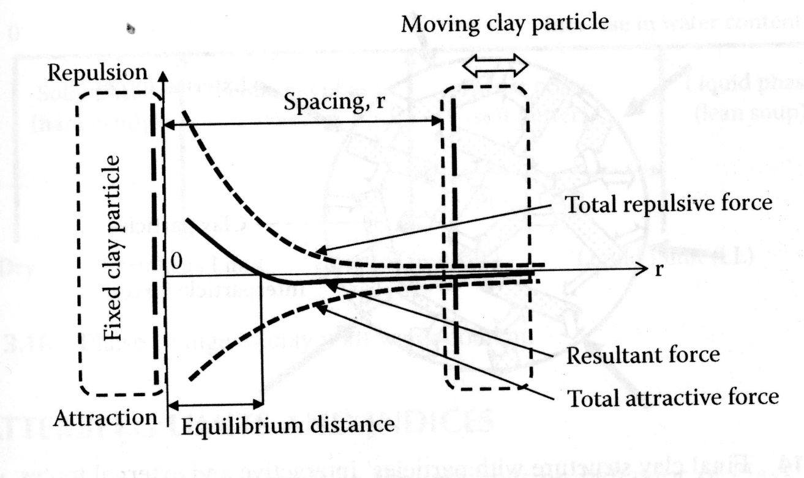
Fig.7.1 Interactive forces versus parallel particle spacing (Ishibashi and Hazarika, 2010)

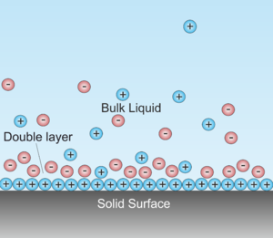
Fig.7.2 Electrical double layer of solid surface (Wikipedia)

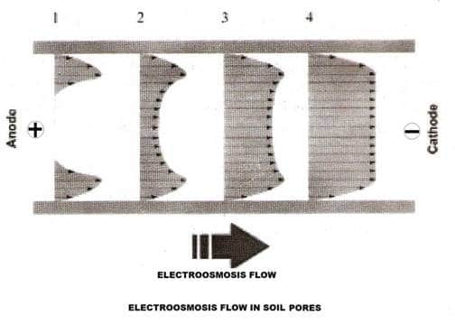
Fig.7.3 Electro-osmotic flow in soil pores

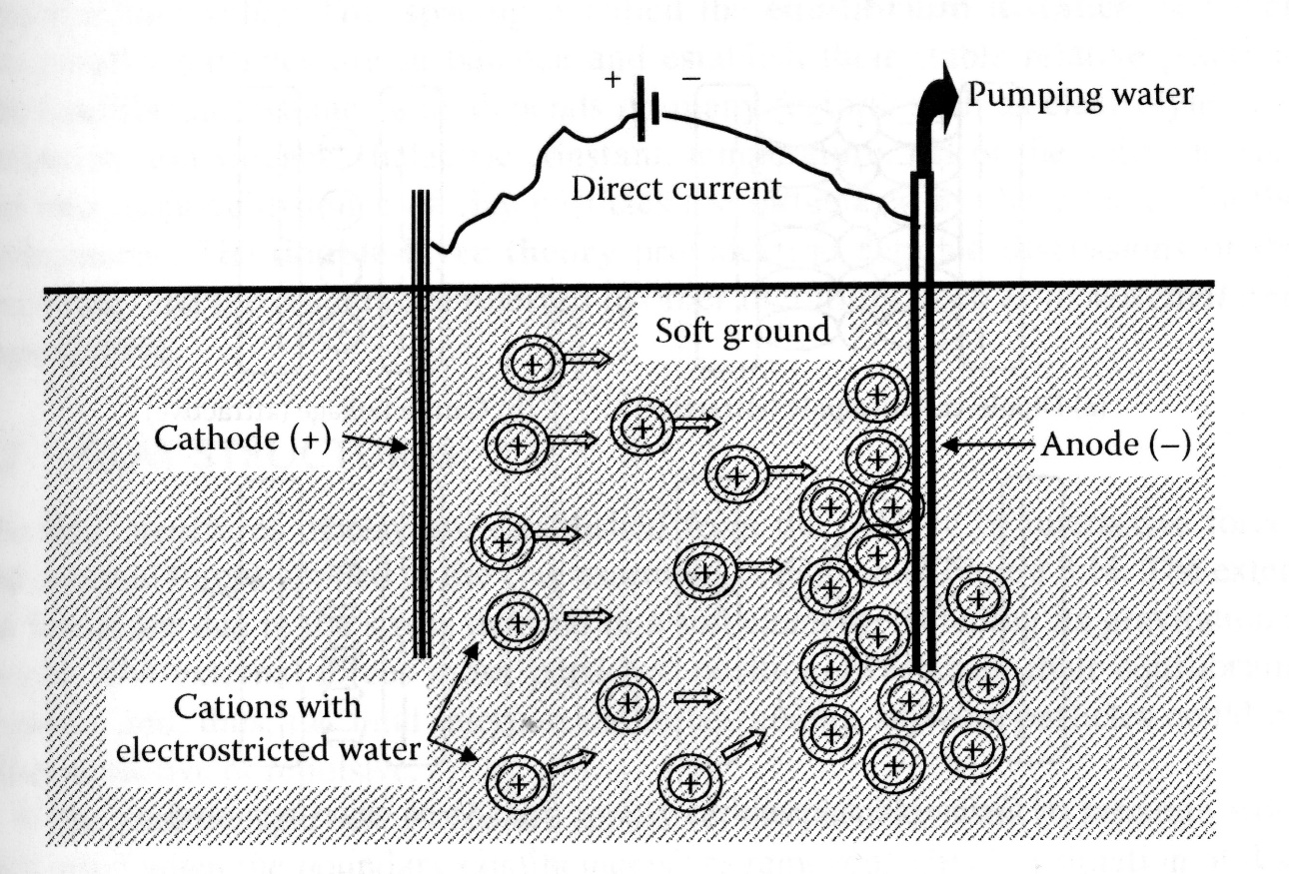

Fig.7.4 Principle of electro-osmosis (Ishibashi and Hazarika, 2010)

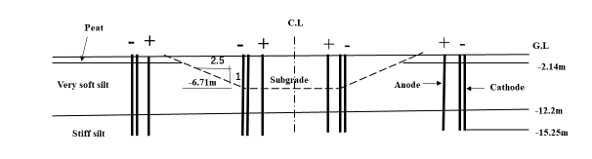

Fig.7.5 Layout of Electro-osmosis System (Casagrande et.al. 1981)

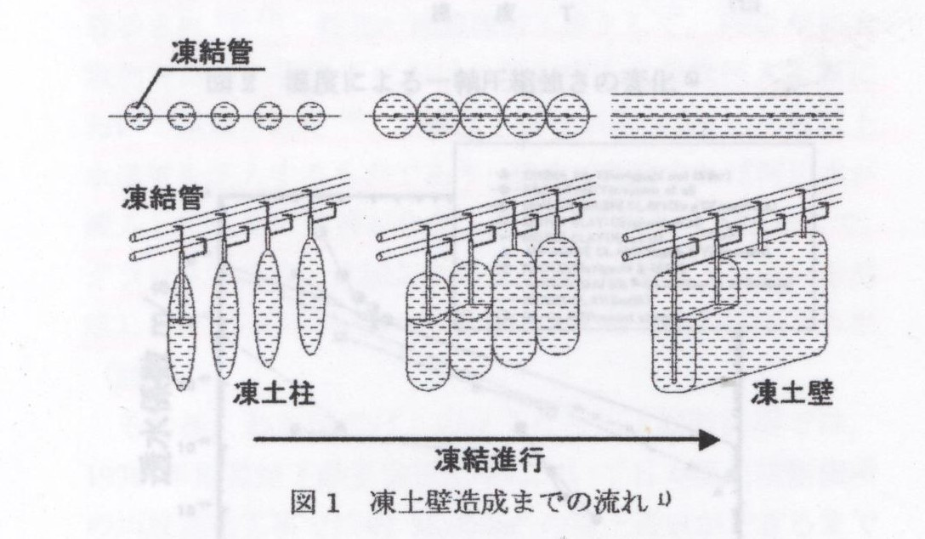
Fig.7.6 Growth Process of Frozen Wall (JGS, 20 )

凍結管 freezing pipe
凍土柱 frozen pillar
凍土壁 frozen wall
凍結進行 progress of freezing

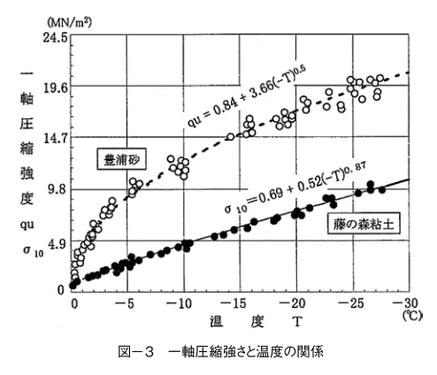
Fig.7.7 Relation between unconfined compression strengths of frozen soils and the freezing temperature (Oguro, 2017)

温度 temperature
一軸圧縮強度 unconfined compression strength
豊浦砂 Toyoura sand
藤の森粘土 Fujinomori clay

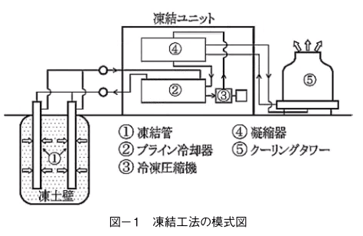
Fig.7.8 Brine System (Oguro, 2017)

凍結管 freezing pipe
ブライン冷却器
冷凍圧縮機凝縮器
クーリングタワー cooling tower
凍土壁 frozen wall

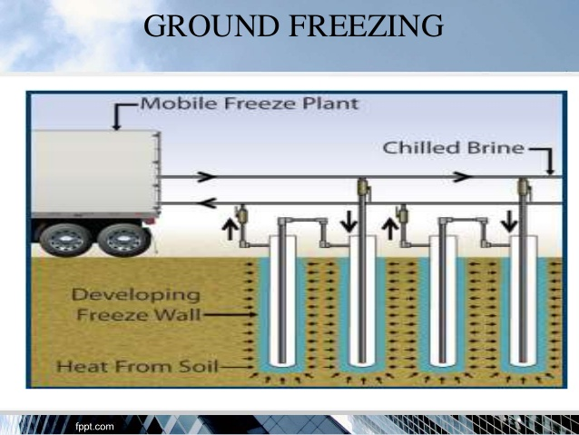
Fig.7.9 Liquefied Gas System ( )

別の図に入れ替えること！

Confirmation of improvement object and condition.
Ground and soil conditions
Outline of construction and construction period
Jobsite condition (underground buried objects etc.)

No
Start of construction
Checking of brine and frozen soil
Yes
temperature
Calculation of freezing time to be required
Decision of freezing plant and equipment

Calculation of freezing speed and freezing load
Arrangement of freezing pipes
Selection of freezing type
Trial calculation of freezing soil mass to be required.
Tentative decision of freezing temperature
Structural calculation of freezing soil

Fig.7.10 Designing Flow of Ground Freezing by Brine System
(Original, Oguro, 2017)
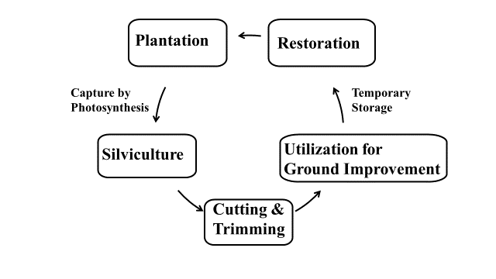
Fig. 7.11 Carbon Cycle of Plant-based Natural Materials
(Original: http://www.yamazaki.co.jp/, Modified by authors)

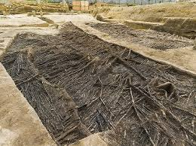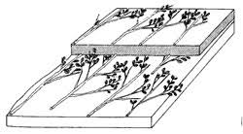
- An example of archaeological remains (b) Illustration
(Nabunken Blog., 2016.6.16) (Amagasaki City, 2007)
Fig. 7.12 LeafFig. Laying Method at Ancient Japan

Primary temporary storage Secondary temporary storage Effective utilization
Reclamation/landfill
Construction materials etc.
Metal resource

Concrete debris waste
Asphalt debris waste
Crushing
Metal resource
Washing
Metal scrap
Mixed refuse
Soil
Non-burnable
Solidification/Stabilization
Burnable
[Incineration]
Wood-only firing furnace
Waste incinerator

Sorting
Washing
Crushing
Waste landfill

Construction materials

Construction materials

Tunami deposit

Tunami deposit
Metal resource etc.

Waste landfill
Construction materials

Thermal recycling
(Power generation
Waste heat utilization)
Board materials or Compost

Washing & Desalting
Non-burnable Mixture

Combustible Mixture

Wood chips
Fig.7.13 Disaster Waste Treatment Flow (Sakakura, 2017)
Waste wood
[Sorting process]
Rough Sorting process
Drying and crushing
Sieving
Magnetic force sorting
Hand sorting
Metal scrap, Waste plastics

